Texas Holdem Final Proposal

We, as a group, decide to continue modifying our game, Texas Holdem. Texas Holdem is a poker game that deals with a deck of 52 cards. At the beginning of the game, each player will have an initial amount of money, referred to as stacks, for betting and will receive 2 cards, referred to as holes. Depending on the stack amount, there will be a minimum amount of money that each player can bet or raise. During the first round of each game, there will be a player assigned as small blind, and the player left of them will be assigned as the big blind. Depending on the number of players, all players will be positioned around the poker table at equal distance apart. After each game, the player that was the big blind will become the small blind and to the left of them will be assigned as the big blind. The small blind will always have to bet the minimum amount required to bet, which is also the betting interval if a player decides to bet and/ or raise, and the big blind will have to raise to twice the amount of what the small blind has bet or higher. Then, during this round, all the other players can only fold (forfeit their cards), call (wager the same amount as the big blind), raise (wager more than the big blind or the previous player/players), or call all-in (wager your whole stack of money). If the previous player wagers, or wagers more than the previous players, the current player will only have limited actions to deploy. Once all the player has called to the highest bet then the next round (the flop) begins. When the flop starts, 3 cards will be distributed to the middle of the table faced up (community cards). These cards are used to determine the highest hand of cards for each player. During this round, the small blind will begin the round with 4 options; fold, bet, check, or call all-in. If the small blind folds or checks, then the next player has the same option as small blind. If small blind decides to bet, or call all-in, then the next players’ options will be limited to fold, call, raise, or call all-in. Once all the players have implemented their actions and/or everyone has called to the highest bet, the next round (the turn) begins. The turn has the same actions as the flop and so does the last round (the river). After the river, everyone’s cards are turned over (assuming there are 2 players or more left in the game), whoever has the highest hand, wins the entire pot. Then, the game resets, the players return all their cards to be shuffled and redistributed and the stack of each player is updated according to their actions from the previous game(s). The entire game ends when all but one player has busted or has lost all their stack of money.

Our game features include the option for the user to select the number of computer players they are willing to play against; it will also include the option of how much money the user wants as his/her initial amount of money to play against other players. The game also features a save button that saves the progress of the user’s game, a quit button that asks for the user’s choice whether or not he/she wants to terminate the game, and a tutorial button that displays the step by step process of playing the game. During each round of the poker game, the user will have three buttons at the bottom of the screen as his/her actions. If he/she selects the bet or the raise button, there will be a slider that lets the user to slide the amount of money he/she is willing to bet and or raise, the user will then click on the enter button to confirm the amount of money he/she is willing to bet or raise. After each round of the game, when all players have either all checked or all called, the game will display a button to continue for the user before the next round of the game begins. During each round of the game, the user will also be able to see all the players’ actions when they fold, called, raised, bet, called all-in, and when they have busted.

Texas Holdem Poker Hands:

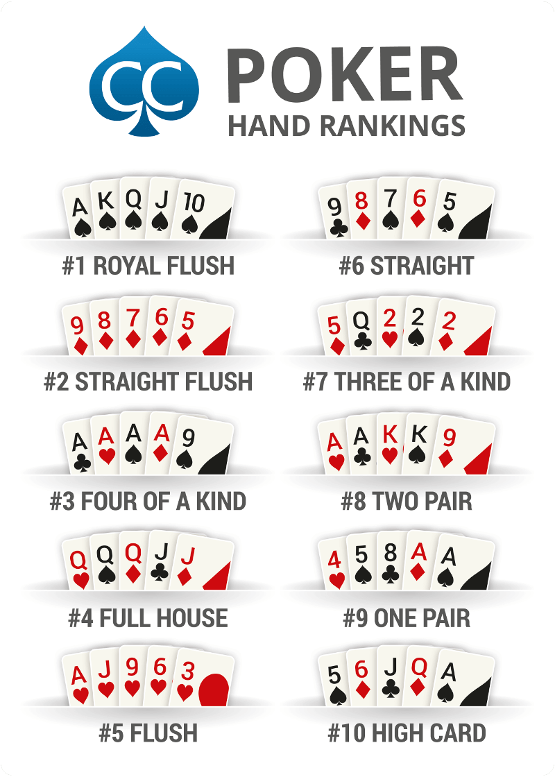

John Lowie

Brayden Schmaltz

Kyle Wen

Adam Hiles